Wild Figures – Numeracy Assessment
Name
Date
Signature

Completing this assessment will enable us to assess your suitability to join the
Wild Figures Wellbeing Programme.
********************************************************************
Please read the following notice for the Green Lane Meadows open day, and then answer the questions to the best of your ability, without using a calculator or using online resources – please circle the correct answer.
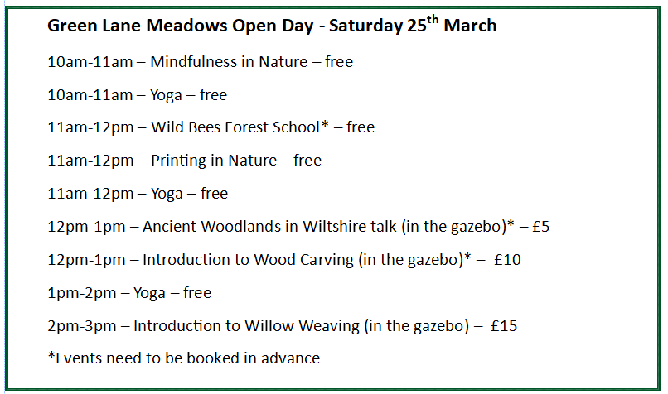
Please note the above event is fictitious for the purposes of this assessment.
- How many events require booking in advance?

1 | 3 | 4 | 6

- What time is ‘Introduction to Wood Carving’?

10am-11am | 11am-12pm | 12pm-1pm | 1pm-2pm

- Which session is the most expensive?

Yoga | Ancient Woodlands in Wiltshire talk
Introduction to Wood Carving | Introduction to Willow Weaving

- Which time slot has the most events?

10am-11am | 11am-12pm | 12pm-1pm | 2pm-3pm

- How many different events are there on the open day?

1 | 3 | 5 | 7

- How many sessions take place in the gazebo?

1 | 2 | 3 | 4

- Please put the following numbers in order, from smallest to largest.

528 | 2398 | 543 | 356 | 21

- Which of these numbers shows eleven thousand and five? Please circle the correct answer:

1105 | 1,100,050 | 110,005 | 11,005 | 11,050

- Please complete the following sum:

58
+32

- Please complete the following multiplication:

27
x45

- What is 2 written as a decimal? _______________________
8

- What is 1m³ in cm? _______________________

- What is 40% of £85? _______________________

- If you are travelling at 50mph how
far will you travel in 30 minutes? ________________________

For office use:
Score: ______/ 14 | Date:
Assessor name: | Assessor signature:
Notes:

